*Florida International University*

*School of Computing and Information Sciences*

Software Engineering Focus

Feature Document

User Story ID 185

**Team Member(s):** Galo Romero

**Project:** Biosensing 2.0

**Product Owner(s)**: Shekhar Bhansali, Yogeswaran Umasankar

**Mentor(s)**: Vishal Chopade, Apurva Sonawane

**Instructor**: Masoud Sadjadi

**User Story Name: Connect Android app with BLE device**

* Description: As a user, I want to connect to BLE device, so that, doctors and myself can monitor my heart rate, alcohol level, sugar level, etc.

Acceptance Criteria

* Android app scans for BLE devices.
* User can select and connect to appropriate BLE device.

**Use Case**

* Name: Connect to BLE device.
* Actor: User
* Preconditions: User has installed Android app on mobile device.
* Description <Flow of events>:

1. The user opens Android app and selects scan from the menu.
2. The app starts scanning for BLE devices.
3. The app displays found BLE devices.
4. The user selects which BLE device to connect to.
5. App connects to selected BLE device.

**Use Case Diagram**

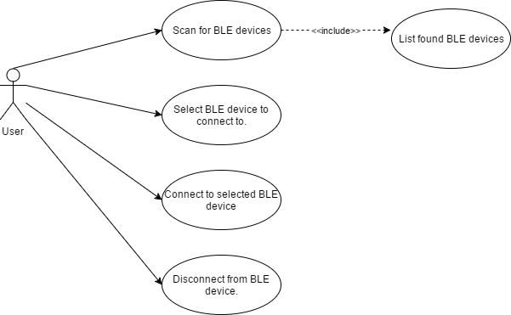

**Sequence Diagram**

SequenceDiagram.png

**Class Diagram**

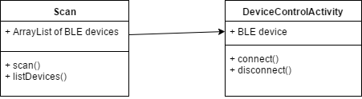

**Unit Test**

* Test case ID: 185-001 (Sunny day)
* Description/Summary of Test:
* Test if Android app can connect to BLE device.
* Pre-condition:
* Android app is installed on mobile device.
* Mobile device has bluetooth capability.
* Expected Results:
* The Android app connects to BLE device.
* Actual Result:
* The user connects to BLE device.
* Status (Fail/Pass):
* Pass.
* Test case ID: 185-002 (Rainy day)
* Description/Summary of Test:
* Notify the user that the mobile device does not support Bluetooth.
* Pre-condition:
* Android app is installed on mobile device.
* Expected Results:
* Display message that Bluetooth is not supported
* Actual Result:
* Bluetooth not supported message displayed.
* Status (Fail/Pass):
* Pass.

**Visual User Guide**

